**A system and Method for Fruit RIPENESS PREDICTION USING TRANSFER**

**LEARNING AND CNN**

**A PROJECT REPORT**

***Submitted by***

**JENCY OLIVIYA K (312820205015)**

**KEERTHANA R (312820205021)**

***in partial fulfillment for the award of the degree***

***of***

**BACHELOR OF TECHNOLOGY**

***in***

## INFORMATION TECHNOLOGY

**AGNI COLLEGE OF TECHNOLOGY**

**THALAMBUR**

**ANNA UNIVERSITY: CHENNAI 600 025**

## MAY 2024

ANNA UNIVERSITY: CHENNAI 600 025

**BONAFIDE CERTIFICATE**

Certified that this project report “**A SYSTEM AND METHOD FOR RIPENESS PREDICTION USING TRANSFER LEARNING AND CNN”** is the bonafide work of **JENCY OLIVIYA K (312820205015), KEERTHANA R (312820205021)** who carried out the project work under my supervision.

|  |  |
| --- | --- |
| **SIGNATURE** | **SIGNATURE** |
|  |  |
| Dr.S. GEERTHIK, M.E, Ph.D. | Dr.S. GEERTHIK, M.E, Ph.D. |
| **HEAD OF THE DEPARTMENT** | **SUPERVISOR** |
| Department of Information Technology | Department of Information Technology |
| Agni College Of Technology,  Thalambur, Chennai - 600130 | Agni College Of Technology,  Thalambur, Chennai – 600130 |

## Submitted for the project viva held on …………………………

**INTERNAL EXAMINER EXTERNAL EXAMINER**

## ACKNOWLEDGEMENT

We would like to express our deepest gratitude to the management of “**AGNI COLLEGE OF TECHNOLOGY”** and would like to thank our respected Principal **Dr. SRINIVASAN ALAVANDAR** for his words of inspiration and for providing necessary facilities to carry out our project work successfully.

We are immensely thankful to our project guide **Dr. S. GEERTHIK, M.E, Ph.D.,** Associate professor Head of the Department, Information Technology for his words of wisdom and his constant source of inspiration.

I would like to offer our heartfelt thanks to **Dr. S. GEERTHIK, M.E, Ph.D.,** Associate professor Head of the Department, He gave valuable suggestion for completing our project work successfully.

We extended our warmest thanks to all the faculty members of our department for their assistance and we also thank all our friends who helped us in bringing out our project in good shape and form.

Finally, we express our sincere benevolence to our beloved parents for their perpetual encouragement and support in all endeavors.

## ABSTRACT

Accurate fruit ripeness prediction is critical for farmers, distributors, and retailers to optimize the food supply chain. Traditional visual inspection methods are subjective, inconsistent, and labour-intensive. This paper proposes a novel system that leverages transfer learning and Convolutional Neural Networks (CNNs) to achieve automated and objective fruit ripeness prediction. Transfer learning significantly reduces training time by utilizing a pre-trained CNN model, which has already learned valuable features from a massive image dataset. CNNs, particularly adept at image recognition, automatically extract relevant features like color, texture, and shapes from fruit images. These features allow the CNN to learn the telltale signs of ripeness and accurately predict the maturity of new fruit images. The proposed system offers several advantages: improved accuracy compared to subjective human assessments, reduced reliance on expert labor, and scalability to handle different fruit types by fine-tuning the model with specific fruit image datasets. Overall, this system utilizing transfer learning and CNNs presents a promising approach for efficient, objective, and cost-effective fruit ripeness prediction in the food supply chain.

|  |  |  |
| --- | --- | --- |
|  | **TABLE OF CONTENTS** |  |
| **CHAPTER NO** | **TITLE** | **PAGE NO** |
|  |  |  |
|  | **ABSTRACT** | II |
|  | **LIST OF FIGURES** | V |
| 1 | 1.1 Introduction | 1 |
|  | 1.2 Objective | 2 |
|  | 1.3 Scope of Project | 2 |
| 2 | **LITERATURE SURVEY** | 4 |
| 3 | **SYSTEM ANALYSIS** | 9 |
|  | 3.1 Existing system | 9 |
|  | 3.2 Proposed system | 10 |
|  | 3.2.1 CNN | 11 |
|  | 3.2.2 Transfer Learning | 12 |
|  | 3.2.3 AlexNet Structure | 12 |
|  | 3.2.4 SoftMax Classifier | 13 |
|  | 3.3 Block Diagram | 13 |
|  | 3.4 Advantages of proposed system | 14 |
| 4 | **SYSTEM REQUIREMENTS** | 15 |
|  | 4.1 Software requirements | 15 |
|  | 4.2 Hardware requirements | 15 |
| 5 | **SYSTEM DESIGN** | 16 |
|  | 5.1 UML Diagrams | 16 |
|  | 5.1.1 Introduction | 16 |
|  | 5.2 usecase Diagram | 17 |
|  | 5.3 Sequence Diagram | 19 |
| 6 | **SYSTEM IMPLEMENTATION** | 20 |
|  | 6.1 List of Modules | 20 |
|  | 6.2 Module Description | 20 |
|  | 6.2.1 Data Collection | 20 |
|  | 6.2.2 Data Preprocessing | 22 |
|  | 6.2.3 Feature Extraction | 24 |
|  | 6.2.4 Model Selection and Metrics | 25 |

|  |  |  |
| --- | --- | --- |
|  | 6.2.5 Disease lesion Segmentation | 25 |
|  | 6.3 Proposed System Methodology | 25 |
|  | 6.3.1 Specify the Goals and Parameters | 25 |
|  | 6.3.2 Gathering and Preparing data | 26 |
|  | 6.3.3 Select the Pretrained model for Transfer  Learning | 26 |
|  | 6.3.4 Model Development | 27 |
|  | 6.3.5 Assessment Assess using the test set | 27 |
|  | 6.3.6 Implementation | 27 |
|  | 6.3.7 Ongoing Enhancement | 29 |
|  | 6.4 Flow chart | 30 |
|  |  |  |
| 7 | **CODING AND TESTING** | 31 |
|  | 7.1 Coding | 31 |
|  | 7.2 Coding standards | 31 |
|  | 7.2.1 Naming Conventions | 31 |
|  | 7.2.2 Value Conventions | 32 |
|  | 7.2.3 Script writing and commenting standard | 32 |
|  | 7.2.4 Message box format | 35 |
| 8 | **CODING** | 37 |
| 9 | **RESULT AND DISCUSSION** | 47 |
|  | 9.1 Results | 47 |
|  | 9.2 Conclusion | 5 |
| 10 | **REFERENCE** | 56 |
| 11 | **APPENDIX-I** | 59 |
|  |  |  |

|  |  |  |
| --- | --- | --- |
|  | **LIST OF FIGURES** |  |
| **FIGURE NO** | **TITLE NO** | **PAGE** |
|  |  |  |
| 1 | Use Case Diagram | 14 |
| 2 | Sequence Diagram | 19 |
| 3 | CNN Architecture | 10 |
| 4 | Sample Dataset | 22 |
| 5 | Flow Chart Diagram | 21 |
| 6 | Home page | 36 |
| 7 | Uploading file page | 37 |
| 8 | Result page 1 | 37 |
| 9 | Result page 2 | 38 |
| 10 | Pre-trained model vs Proposed model accuracy | 50 |
| 11 | Training and validation accuracies | 51 |

**CHAPTER 1**

* 1. **Introduction**

One of the most important difficulties in agricultural technology is accurately classifying and determining fruit maturity. This role is critical in improving the quality control systems throughout the supply chain, ensuring that end consumers receive items that are not only high quality but also at the appropriate stage of ripeness. Traditional techniques of fruit classification and maturity detection are frequently manual, time-consuming, and prone to human mistake, resulting in significant food waste and financial losses. Convolutional Neural Networks (CNN) have opened up new paths in computer vision by providing robust methods for image categorization and analysis. CNNs, with their deep learning capabilities, have demonstrated amazing ability in learning complicated patterns from data, making them perfect for fruit classification and ripeness detection. However, training neural networks from scratch necessitates significant computer resources and big datasets, which might be restricting in practical applications.

To solve these restrictions, our project, "Fruit Classification and Ripeness Detection Using CNN with Transfer Learning," presents a novel solution. We may considerably streamline the learning process by using the concept of transfer learning, which involves using a model generated for one task as the starting point for a model for another. Transfer learning enables the system to apply knowledge from pre-trained models to huge and diverse datasets, improving its capacity to reliably distinguish and categorize distinct fruit species and ripeness stages. This research seeks to bridge the gap between modern computer vision techniques and their practical applications in agriculture. By combining the power of CNNs with the efficiency of transfer learning, we can create a system that is not only accurate and fast, but also adaptive and resource efficient. This technology has the potential to revolutionize the fruit industry's supply chain management, from harvesting to retail, eliminating food waste and guaranteeing that produce matches consumer expectations.

In this project, we will look at the methods for implementing CNNs with transfer learning for fruit classification and ripeness detection, as well as the potential repercussions on the fruit business and the larger implications for sustainable agriculture practices.

* 1. **Objective**

The project's objectives revolve around revolutionizing fruit detection and classification through the utilization of Convolutional Neural Networks (CNNs) and Deep learning techniques. The primary aims include crafting a robust CNN model for accurate and efficient fruit categorization, implementing a specialized module to assess fruit ripeness levels, and designing a user-friendly interface for real-time input and output. The project seeks to enhance operational efficiency by reducing manual intervention, ensuring scalability for high-throughput scenarios, and addressing ethical concerns related to biases and privacy. With a focus on technological innovation, the project aspires to set new standards in fruit processing and distribution by combining accuracy, automation, and responsible technology deployment.

**1.3 Scope of Project**

The project's scope encompasses the development of a robust system for fruit classification and ripeness detection, leveraging the integration of image processing, computer vision, and Convolutional Neural Networks (CNN) techniques. This involves curating an extensive dataset of fruit images, preprocessing them to enhance quality, and designing a specialized CNN architecture to extract intricate visual features. The model will be trained to accurately classify fruit types and estimate their ripeness levels, with a focus on real-time performance. A user-friendly interface will facilitate easy input of fruit images for instant classification and assessment. The project's significance lies in its potential to reshape fruit sorting, supply chain efficiency, and quality assurance while addressing sustainability goals by minimizing food wastage.

**CHAPTER 2**

**LITERATURE SURVEY**

**PAPER 1:**

**TITLE:** Highly Efficient Machine Learning Approach for Automatic Disease and Color Classification of Olive Fruits

**AUTHOR:** SUHARJITO, MUHAMMAD ASROL, DITDIT NUGERAHA UTAMA, FRANZ ADETA JUNIOR, MARIMIN4 ,

**YEAR:** 2024

**ABSTRACT:**

The classification of the ripeness degree of oil palm fruit has attracted the attention of numerous researchers. However, there are still many challenges due to constraints in the dataset, methodologies used, and variations in the use of data categories. Detecting oil palm fruit bunches accurately is crucial, given their complex shape and characteristics, particularly when different ripeness categories are present in a pile of oil palm. Most studies utilize oil palm images or the color spectrum of oil palm fruit to classify the level of ripeness. However, these methods are not real-time and lack efficiency. This study proposes a real-time model for determining the ripeness degree of oil palm using a smartphone and video data as input, incorporating modifications to the object detection approach. The research process involves collecting videos of palm oil piles using smartphones in the grading area of the palm oil industry. The videos are then pre-processed and labelled for the object detection and classification process. A detection and classification model is developed using the YOLOv4 approach with several performance improvements, enabling implementation on smartphones. The best-performing model is tested for detecting and classifying the ripeness of fresh fruit bunches using an android-based smartphone. The testing results, based on the map value, demonstrate that the YOLOv4 model with 16 quantization performs 12% better than YOLOv4 Tiny. Based on the test results at the grading location, this model can efficiently detect fruit bunches that do not meet the quality standards.

**PAPER 2:**

**TITLE :** Deep Learning and Computer Vision for Estimating Date Fruits Type, Maturity Level, and Weight

**AUTHOR:** MOHAMMED FAISAL, FAHAD ALBOGAMY, HEBAH ELGIBREEN , MOHAMMED ALGABRI, AND FATTOH ABDU ALQERSHI

**YEAR:** 2020

**ABSTRACT:**

According to the Food and Agriculture Organization, the world production of date fruits is 8,526,218 tons and around 1,302,859 tons in the Kingdom of Saudi Arabia (KSA) in 2018. There are several types of date fruits, and the most common in KSA are Barhi, Khalas, Meneifi, Naboot Saif, and Sullaj. Moreover, there are around five main maturity levels: Immature, Khalal, Khalal with Rutab, Pre-Tamar, and Tamar. Harvesting date fruits is performed according to its maturity level and type, which is a critical decision that significantly affects profit. In this paper, we propose a smart harvesting decision system to estimate date fruits type, maturity level, and weight using computer vision (CV) and deep learning (DL) techniques. The proposed system consists of three sub-systems: Dates maturity estimation system (DMES), type estimation system (DTES), and dates weight estimation system (DWES). We utilized four DL architectures, including ResNet, VGG-19, Inception-V3, and NASNet for both DMES and DTES and support vector machine (SVM) (regression and linear) for DWES. We evaluated the performance of the proposed system using the dataset collected by the Center of Smart Robotics Research.. DWES achieved a maximum performance of 84.27% using SVM-Linear.

**PAPER 3:**

**TITLE :** A Two-Stage Feature Selection Approach for Fruit Recognition Using Camera Images With Various Machine Learning Classifiers

**AUTHOR:** TRI TRAN MINH HUYNH, TUAN MINH LE, LONG TON THAT, LY VAN TRAN, SON VU TRUONG DAO

**YEAR:** 2022

**ABSTRACT:**

Fruit and vegetable identification and classification system is always necessary and advantageous for the agriculture business, the food processing sector, as well as the convenience shops and hypermarkets where these products are sold. Therefore, it is necessary to build an effective automated tool to meet the needs of the market by boosting the outcome, in order to improve economic efficiency. In this paper, a two-stage model is proposed to recognize fruits using camera images. We employed a Densnet121 to get the features from the fruits dataset in the first module. In the second stage, we utilize a feature subset selection method to choose the most significant features for recognizing fruits from the images of the fruits. In this study, Adaptive particle - Grey Wolf Optimization (APGWO) has been applied for choosing the most pertinent features. The final subset feature has been used for recognizing fruits using several machine learning classifiers, namely K-Nearest Neighbor (KNN), Support Vector Machine (SVM), Decision Tree (DT), Random Forest (RF), and Multilayer Perceptron (MLP). The proposed research’s experimental results are highly effective; the training time of proposed models is reduced to over 50%, .

**PAPER 4:**

**TITLE :** YOLO-Based Deep Learning Framework for Olive Fruit Fly Detection and Counting

**AUTHOR:** NARIMAN MAMDOUH AND AHMED KHATTAB

**YEAR:** 2021

**ABSTRACT:**

The olive fruit fly can damage up to 100% of the harvested fruit and can cause up to 80% reduction of the value of the resulting olive oil. Therefore, it is important to early detect its presence in the olive orchard to take the appropriate chemical or biological countermeasures as early as possible. Traps filled with attractant pheromones are typically deployed across the orchard to attract and capture the flies. Traditionally, the captured flies were manually counted which is error prone. Recently, the traps are employed with cameras and communication devices to send pictures of the captured flies to experts for analysis which is also error prone and inefficient. Consequently, machine and deep learning have been exploited to develop fully automated and accurate detection that does not include human in the loop. Such a learning problem is challenging due to the small size of the detected object, the differences in the light conditions at which pictures were taken, and the lack of enough data to train the learning model. In this paper, we present a deep learning framework for detecting and counting the number of olive fruit flies that exploits data augmentation to increase the dataset size, includes negative samples in the training to improve the detection accuracy, and normalizes the images to the color of the trap background, i.e., yellow, to unify the illumination conditions. The results of the proposed framework show a precision of 0.84, a recall of 0.97.

**PAPER 5:**

**TITLE :** Analysis of Fruit Images With Deep Learning: A Systematic Literature Review and Future Directions

**AUTHOR:** SEBASTIÁN ESPINOZA, CRISTHIAN AGUILERA , LUIS ROJAS , PEDRO G. CAMPOS

**YEAR:** 2023

**ABSTRACT:**

The application of Deep Learning models in fruit analysis has garnered significant attention due to its potential to revolutionize the agricultural sector and enhance crop monitoring. This paper presents a comprehensive review of recent research efforts in fruit analysis using Deep Learning techniques. The study delves into model selection, dataset characteristics, evaluation metrics, challenges, and future directions in this domain. Various model architectures, including classical Convolutional Neural Networks (CNNs) and advanced detection models like R-CNN and YOLO, have been explored for tasks ranging from fruit classification to detection. Evaluation metrics such as precision, recall, F1-score, and mean Average Precision (mAP) have been commonly used to assess model performance. Challenges, including data scarcity, labeling complexities, variations in fruit characteristics, and computational efficiency, have been identified and discussed. The paper also presents an overview of available datasets, encompassing both proprietary and publicly accessible sources. Future research directions involve exploring enhanced data augmentation, multi-modal integration, knowledge transfer across species, robustness in dynamic environments, improved computational efficiency, and practical integration of models into real-world agricultural systems. This review provides valuable insights for researchers and practitioners aiming to leverage Deep Learning for fruit analysis in the pursuit of sustainable agriculture and food production.

## CHAPTER 3

**SYSTEM ANALYSIS**

## Existing System

The Existing system of the project emphasizes the detection and classification of fruits with image processing techniques The input is given in the form of images and classify the variety of fruits. This is done using image processing technique and shows less accuracy in the detection and classification of the fruits. It also has some limitations like low accuracy prediction, misclassifications between fruits and cannot detect whether the fruit is riped or not as well as the ripeness levels. This leads to the limited usage of the project. It causes a struggle to accurately distinguish between fruits with subtle visual differences and lack the efficiency required for large-scale sorting. Moreover, the traditional system cannot effectively assess internal attributes like ripeness. As a result, there is a need for a more advanced and automated solution that can leverage modern technologies like Convolutional neural network(CNN) and Deep learning to achieve accurate and efficient fruit detection and classification.

**Disadvantages**

* The existing system's image processing techniques yield suboptimal accuracy in fruit detection and classification, leading to misclassifications and unreliable results.
* The current system lacks the capability to determine fruit ripeness levels, restricting its usefulness for quality control and consumer satisfaction.
* The inability to efficiently assess internal attributes like ripeness and quality limits the system's effectiveness in large-scale fruit sorting operations.

## Proposed System

## 

The proposed system represents an advanced approach to fruit detection and classification by harnessing the capabilities of Convolutional Neural Networks (CNNs) and deep learning. By integrating a specialized CNN architecture, the system will enable accurate and efficient classification of a diverse range of fruits based on their visual attributes. Additionally, the system will address the limitations of the existing methods by incorporating a ripeness detection component, enhancing quality control and decision-making. With real-time performance, scalability, and reduced dependency on manual intervention, the proposed system aims to provide a comprehensive and automated solution for precise fruit classification and ripeness assessment, ultimately contributing to improved efficiency and accuracy in various fruit-related industries. It also detects whether the fruit is riped or not and predicts the ripeness levels so that it will be a real time application with necessary classification.

The suggested method for fruit classification and ripeness detection combines sophisticated Convolutional Neural Networks (CNN) and transfer learning to improve accuracy and efficiency in agricultural sorting procedures. The system captures and produces various fruit images by employing high-resolution image acquisition and preprocessing techniques. The core is a CNN model that uses transfer learning from pre-trained datasets to minimize training time and resource requirements while adapting to individual fruit classification and ripeness assessment tasks. This technology not only divides fruits into several groups, but it also determines their ripeness level and displays the results in an easy-to-use interface. It can also integrate with automated sorting technology to improve sorting efficiency. This approach is resilient and has continuous learning and feedback methods to improve accuracy over time and innovative approach to modernizing the agricultural supply chain**.**

**3.2.1 Convolutional Neural Networks**

Convolutional neural networks (CNNs) are a class of deep learning models specifically designed to process structured raster data such as images(Refer Fig 3.2.1.1). CNNs have proven to be highly effective in image classification, object detection, and various computer vision tasks. Technically, deep learning CNN models to train and test, each input image will pass it through a series of convolution layers with filters (Kernels), Pooling, fully connected layers (FC) and apply SoftMax function to classify an object with probabilistic values between 0 and 1. The below figure is a complete flow of CNN to process an input image and classifies the objects based on values.

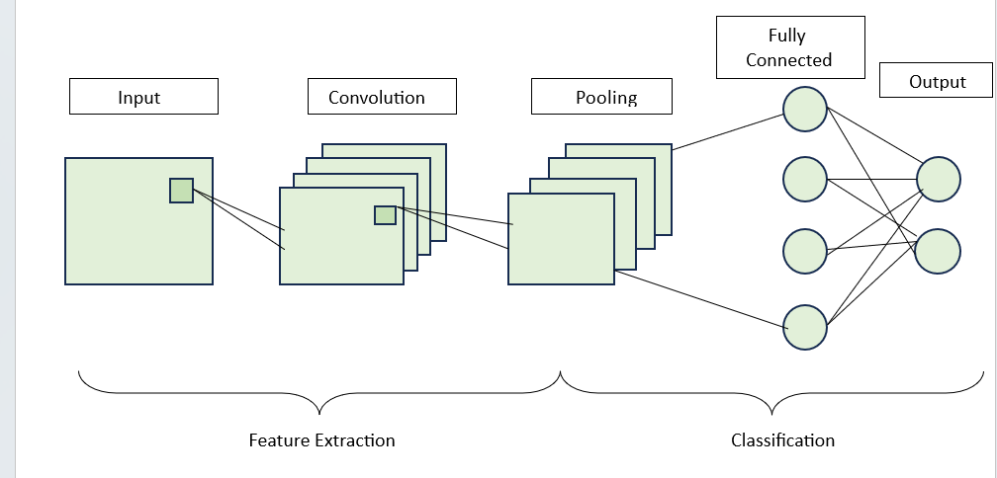

**Fig.3.2.1.1 CNN architecture**

**3.2.2 Transfer Learning**

In deep learning, transfer learning is a technique for training neural network models for problems similar to those being solved. Transitional learning has the advantage of reducing the training time of the training model and may reduce generalization. The current work includes performance comparisons of CNN model with LeNet-5, Vgg-16, Vgg-19 and AlexNet models.

**3.2.3 Alex Net Structure**

This is an eight-layer weighted model, with the first five being convolutional layers and the last three being fully connected layers. The first layer of the Alex Net architecture processes the input image resolution of 150 x 150 x 3 and applies 96 convolutional filters with 11 x 11 resolution. The first layer's output is used as the input for the second layer, which employs 256 convolutional filters with a 5 x 5 resolution. In addition, the third and fourth layers employ 384 convolutional filters with a resolution of 3x3. The fifth convolutional layer has 256 kernels with 3x3 resolution. Through batch normalization, all five layers of Alex Net use maximum pooling of 2x2 resolution. The use of an adequate activation function motivates us to enhance our accuracy of our method. As a result, when selecting the activation function, we ensure that the gradient function converges quickly and that the activation function is not 0 at infinity. The ReLU activation function and its derivate are shown in Equations (1) and (2) in our study.

𝑓(𝑥)=𝑚𝑎𝑥 (0, 𝑥) …. (1)

𝑓′(𝑥) = {1, 0, 𝑖𝑓 𝑥>0 𝑜𝑡ℎ𝑒𝑟𝑤𝑖𝑠𝑒…. (2)

Equation (2) shows that the derivative of the ReLU function is always 1 on the positive half-axis of x and always 0 on the negative half-axis of x. In the first five convolutional layers, the ReLU function is utilized. Furthermore, the output from the first five levels is transmitted to three completely connected layers, the first two of which comprise 4096 units and the last fully linked layer contains 1000 units. The final output layer, which consists of 6 units, employs the SoftMax activation function. After the Alex Net has processed the data, the following stage is transfer learning, as detailed below.

**3.2.4 Softmax Classifiers**

SoftMax classifiers are neural network-based classifiers that are often employed in multi-class classification applications such as fruit categorization. In the case of fruit classification, an input layer representing fruit attributes (such as color, size, texture, and so on) and an output layer with nodes corresponding to distinct fruit classes (e.g., apple, banana, orange) would be usual.

**3.3 Block Diagram**

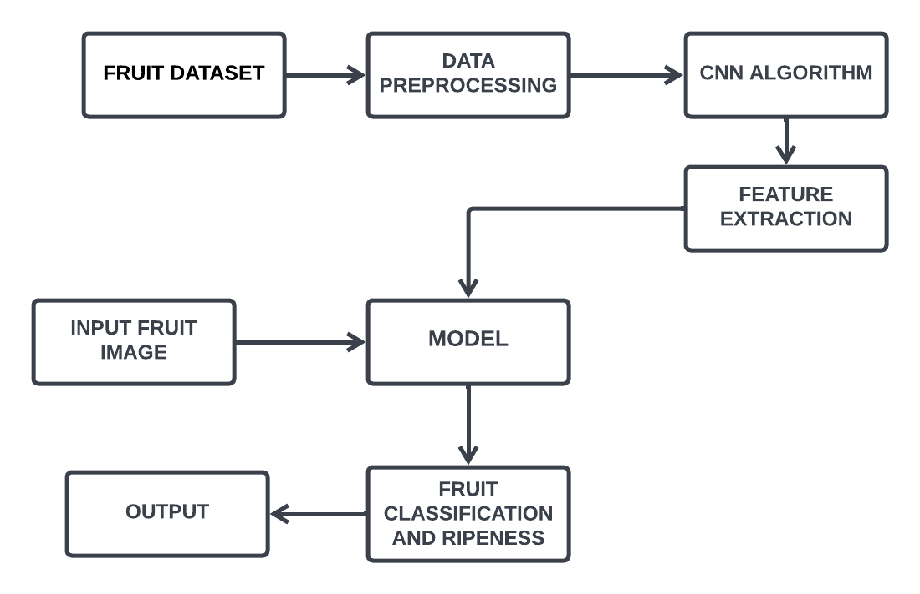

**Fig.3.3.1 Block diagram**

## Advantages of Proposed System

* Leveraging Convolutional Neural Networks (CNNs) and deep learning techniques, the proposed system achieves higher accuracy in fruit detection and classification, minimizing misclassifications and errors.
* The integration of a ripeness detection component allows the system to accurately assess the ripeness levels of fruits, enabling better quality control and decision-making throughout the supply chain.
* Designed for scalability, the system can handle large volumes of fruit images, making it ideal for high-throughput environments such as sorting facilities.

## CHAPTER 4

**SYSTEM REQUIREMENTS**

## Software Requirements

* Operating System - Windows 7/8/10
* Front End - Html,Css
* Scripts - Python language
* Tool - Python IDLE

## Hardware Requirements

# Processor - Intel

* Speed - 1.1 GHz
* RAM - 8 Gb

## CHAPTER 5

## SYSTEM DESIGN

* 1. **UML Diagrams**

## Introduction

Unified Modeling Language (UML) is a standardized general- purpose modeling language in the field of software engineering. The standard is managed and was created by the Object Management Group. UML includes a set of graphic notation techniques to create visual models of software intensive systems. This language is used to specify, visualize, modify, construct and document the artifacts of an object oriented software intensive system under development. There are given as below:

* Sequence diagram
* Use case diagram
* Activity diagram
* Collaboration diagram
* Dataflow diagram

**Characteristics of UM**

* It is a generalized modeling language.
* It is different from software programming languages such as Python, C, C++, etc.
* It is a pictorial language which can be used to generate powerful modeling elements.
* It is related to object-oriented designs and analysis.

**Five Rules For Better Uml Diagrams**

* To avoid large diagrams with too many items.
* Avoid any two lines in your diagram crossing each other.
* Lines in a diagram should go only horizontal or vertical with only right angles.
* Parent elements are higher than the child elements in generalization or realization hierarchies.
* Diagrams should be nice and clean

## Use Case Diagram

A Use case Diagram is used to present a graphical overview of the functionality provided by a system in terms of actors, their goals and any dependencies between those use cases.

Use case diagram consists of two parts:

## Use case:

A use case describes a sequence of actions that provided something of measurable value to an actor and is drawn as a horizontal ellipse.

## Actor:

An actor is a person, organization or external system that plays a role in one or more interaction with the system.

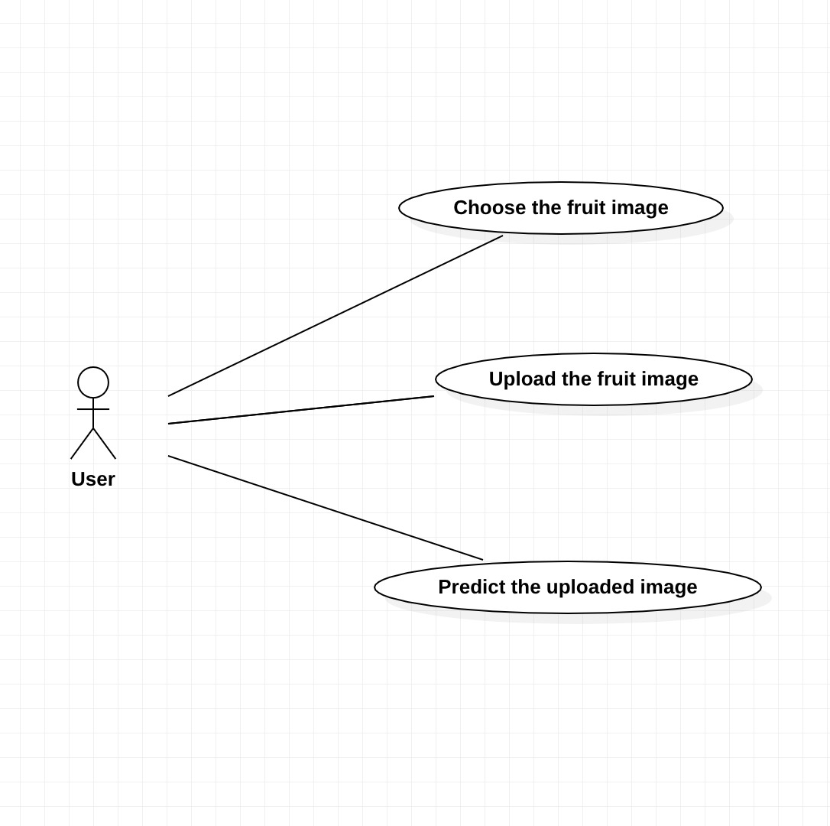

**Fig.5.2.1 Use case diagram**

## Sequence Diagram

## A sequence diagram is a type of interaction diagram because it describes how—and in what order—a group of objects works together.

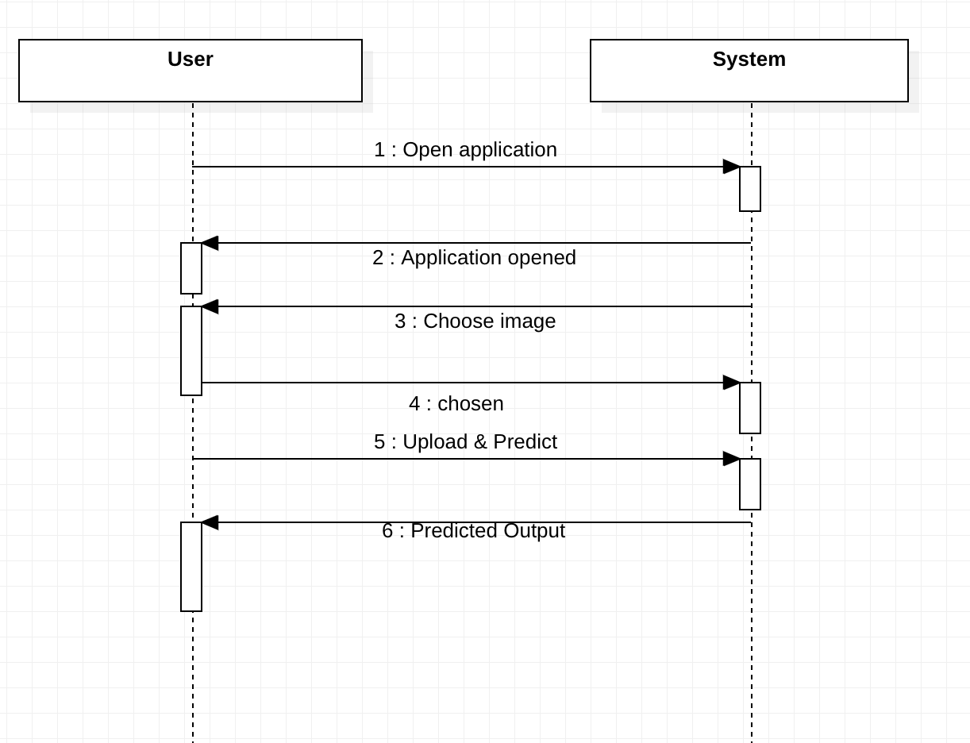

**Fig.5.2.2 Sequence diagram**

## CHAPTER 6

**SYSTEM IMPLEMENTATION**

## List Of Modules

* Dataset Collection
* Data Preprocessing
* Feature Extraction
* Model Selection and Metrics
* Diease lession segmentation
  1. **Module Description**

**6.2.1 Dataset Collection**

The dataset for fruit classification and ripeness assessment using deep learning was carefully gathered from diverse sources, including vendors, markets, and farms. Each fruit was inspected, labeled with its species and ripeness stage, and photographed under various conditions. Data augmentation techniques were applied to enrich the dataset. The collection process focused on balance and accuracy, ensuring representation across fruit types and ripeness levels. This comprehensive dataset serves as the foundation for developing an effective deep learning model for fruit classification and ripeness assessment.

Define the Scope: Decide which fruits you want to include in your dataset. Consider factors like popularity, variety, and availability.

Image Acquisition: Take high-resolution images of the fruits. Ensure that the images capture different aspects such as color, size, shape, and texture variations. It's also beneficial to include images of fruits at different stages of ripeness.

Annotation: Annotate the images with bounding boxes or segmentation masks to indicate the location of each fruit in the image. This step is crucial for training supervised learning models.

Data Augmentation: Augment the dataset by applying transformations such as rotation, flipping, scaling, and brightness adjustments to increase the diversity of the dataset. This helps improve the model's robustness.

Quality Control: Review the dataset to ensure image quality, consistency in annotations, and a balanced representation of different classes (fruits).

Splitting the Dataset: Divide the dataset into training, validation, and test sets. The training set is used to train the model, the validation set is used to tune hyperparameters and monitor performance during training, and the test set is used to evaluate the final model's performance.

Metadata: Optionally, you can include metadata such as fruit labels, image capture date, and any other relevant information that might be useful for analysis.

Sharing and Documentation: If you plan to make the dataset publicly available, ensure that you provide proper documentation including information about the dataset, citation requirements, and any terms of use.

Data Privacy and Ethics: Respect privacy concerns and ethical considerations when collecting and sharing the dataset, especially if it includes images of individuals handling the fruits.

Continuous Updates: Consider updating the dataset periodically to include new fruits, variations, or improvements based on feedback and advancements field. 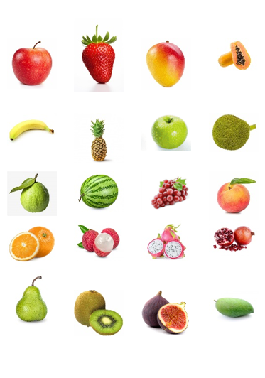

**Fig.6.1 Sample Dataset**

**6.2.2 Data Preprocessing**

In this module, the collected dataset undergoes preprocessing steps to prepare it for training and analysis. This includes tasks such as image resizing, normalization, and augmentation to enhance the quality and diversity of the dataset. Additionally, any noise or inconsistencies in the data may be addressed during this stage to improve the overall performance of the model.

Image Resizing: Resize all images to a uniform size. This step ensures that all images have the same dimensions, which is necessary for feeding them into a neural network. Common image sizes for preprocessing include 224x224, 256x256, or 512x512 pixels.

Normalization: Normalize pixel values to a common scale. This usually involves scaling pixel values to be within the range of 0 to 1 or -1 to 1. Normalization helps in stabilizing the training process and improves convergence.

Data Augmentation: Augment the dataset by applying transformations to the images. Common augmentation techniques include rotation, flipping, scaling, cropping, and adjusting brightness and contrast. Data augmentation increases the diversity of the dataset and helps prevent overfitting.

Annotation Parsing: Parse the annotations associated with each image. Depending on the annotation format, you may need to extract bounding box coordinates or segmentation masks indicating the location of fruits in the image. This step is essential for supervised learning tasks.

Balancing Classes: Ensure a balanced representation of classes (fruits) in the dataset. If certain fruits are underrepresented, you may need to oversample or undersample the dataset to achieve class balance. Class imbalance can lead to biased models.

Data Splitting: Split the dataset into training, validation, and test sets. The training set is used to train the model, the validation set is used to tune hyperparameters and monitor performance during training, and the test set is used to evaluate the final model's performance.

Feature Extraction: Extract features from the images if using traditional machine learning algorithms instead of deep learning. Common features include color histograms, texture features, and shape descriptors.

Dimensionality Reduction: If the feature space is high-dimensional, consider applying dimensionality reduction techniques such as principal component analysis (PCA) or t-distributed stochastic neighbor embedding (t-SNE) to reduce the computational complexity and improve model performance.

Handling Missing Data: Check for missing data or corrupted images and handle them appropriately. Depending on the severity of missing data, you may choose to remove affected samples or perform data imputation.

Data Cleaning: Perform any additional cleaning steps such as removing duplicate images, correcting mislabeled data, or removing outliers that might adversely affect model training.

**6.2.3 Feature Extraction**

In fruit classification and ripeness assessment using deep learning, feature extraction is vital for identifying key characteristics from input images. Convolutional Neural Networks (CNNs) are commonly used to automatically extract relevant features from fruit images. Pre-trained CNN architectures like ResNet or VGG are often employed, capturing low-level features such as edges and textures in early layers and higher-level features like shapes in deeper layers. Transfer learning adapts these features to the specific task by fine-tuning the pre-trained model on the fruit dataset. Techniques like spatial pyramid pooling or global average pooling effectively aggregate features from different spatial locations. This process enables the model to discern distinctive features for accurate classification and ripeness assessment. The choice of feature extraction techniques depends on factors such as the complexity of the dataset, computational resources, and the specific requirements of the fruit detection task. Experimentation with different feature sets and combinations is often necessary to achieve optimal performance.

Bottom of Form

**6.2.4 Model Selection And Metrics**

In fruit classification and ripeness assessment using deep learning, model selection involves picking a suitable architecture like ResNet or VGG, while training metrics such as accuracy and loss monitor progress. Evaluation metrics like precision and recall gauge classification performance, and regression metrics like MAE measure ripeness assessment accuracy. Choosing the right metrics ensures the effectiveness of the model for accurate fruit classification and ripeness evaluation.

**6.2.5 Disease Lesion Segmentation**

Classification and ripeness assessment of fruits involve two main tasks: identifying the fruit type and determining its ripeness level. For classification, deep learning techniques like CNNs are used to recognize different fruit types based on visual features such as shape and color. Ripeness assessment focuses on analyzing cues like color and texture to determine if a fruit is unripe, ripe, or overripe. By combining these capabilities, applications like quality control and consumer information can be improved. Deep learning enables accurate and efficient fruit analysis, benefiting industries such as agriculture and food technology.

## Proposed System Methodology

**6.3.1. Specify The Goals and Parameters**

Name the Fruits:

Specify exactly which kinds of fruits your system will consider ripe. Certain fruits may have unique visual traits, necessitating the use of particular models or datasets.

Establish Ripeness Categorization:

Identify the ripeness categories (such as unripe, ripe, and overripe) that are pertinent to your application, as well as any other characteristics you wish to forecast (such as hardness and color intensity).

**6.3.2. Gathering and Preparing Data**

Gather the Image Dataset:

Assemble a varied and representative collection of excellent photos that show different stages of ripeness for every variety of fruit.

Labeling:

Add the appropriate ripeness labels to the photos. To ensure successful model training, make sure labelling is precise and consistent.

Data Enrichment:

Expand the dataset by using transformations (such as rotation, scaling, and flipping) to strengthen the model's resilience and enhance its generalization.

Normativeization:

To guarantee that the neural network receives consistent input, normalize pixel values to a standard scale.

**6.3.3. Select The Pre-Trained Model For Transfer Learning**

Choose a CNN model that has already been trained using a sizable dataset (such as ImageNet). Popular options are ResNet, Inception, VGG, and Mobile Net.

Modify the Model Architecture:

Adjust the final few layers of the trained model to correspond with the quantity of classes and characteristics in your task of predicting the maturity of your fruit.

Put it in freeze Already-trained Layers:

To keep learnt features from being modified during training on your particular dataset, freeze the weights of the first few layers in the pre-trained model.

**6.3.4. Model Development: Divided Dataset**

Make training, validation, and test sets out of the dataset. The validation set aids in hyperparameter tuning, the test set assesses final performance, and the training set is utilized to train the model.

Configuration for Training:

Set up the model for training by selecting the learning rate, optimization technique, and other hyperparameters.

Adjusting:

Use your dataset to train the model, adjusting the final layers' weights to suit the particular fruit ripeness prediction objective.

**6.3.5. Assessment: Assess Using the Test Set**

Using the proper assessment measures (accuracy, precision, recall, F1 score), evaluate the model's performance on the test set.

Repeated Fine Tuning:

Refine the model architecture or change the hyperparameters in light of the evaluation's findings, if needed. Continue iterating until the performance is up to par.

**6.3.6. Implementation**

Export Model

The trained model can be exported and used later. Preprocessing stages, weights, and model architecture should all be saved.

Combination

Make that the model is compatible with the target platform (local server, cloud, mobile app) by integrating it into the deployment environment.

Conclusion:

Use the inference procedure to make predictions in real time. Make that the training pipeline's preprocessing of the incoming data is consistent.

Data Collection and Preprocessing:

Collect a dataset of fruit images with corresponding labels.

Preprocess the images by resizing them to a uniform size, normalizing pixel values, and optionally augmenting the dataset to increase diversity.

Model Selection

Choose a suitable classification model architecture based on the size of the dataset, computational resources, and performance requirements.

Common choices include Convolutional Neural Networks (CNNs) such as VGG, ResNet, or MobileNet, or simpler models like Support Vector Machines (SVMs) or Random Forests.

Training

Split the dataset into training, validation, and test sets.

Train the chosen model on the training data using appropriate loss functions and optimization algorithms.

Monitor the model's performance on the validation set and adjust hyperparameters as needed to prevent overfitting.

Evaluation

Evaluate the trained model on the test set to assess its performance in real-world scenarios.

Calculate metrics such as accuracy, precision, recall, and F1-score to measure classification performance.

Visualize performance metrics using confusion matrices, ROC curves, or precision-recall curves.

Fine-tuning (Optional):

Optionally, fine-tune the pre-trained model on the fruit classification task to improve performance further.

Fine-tuning involves retraining the model on the target dataset while freezing some layers and updating only the weights of selected layers.

Deployment

Deploy the trained model to a production environment or integrate it into an application or system where fruit classification is required.

Ensure that the deployment pipeline is robust and efficient, with considerations for inference speed, scalability, and resource constraints.

Monitoring and Maintenance:

Monitor the deployed model's performance over time and update it periodically with new data or retraining to maintain accuracy and adapt to changes in the fruit distribution.

Documentation and Sharing

Document the implementation process, including code, model architecture, training procedures, and performance evaluation.

Share the implementation with relevant stakeholders or the broader community, along with any datasets or trained models, to facilitate reproducibility and collaboration.

**6.3.7. Ongoing Enhancement: Observation**

Establish monitoring systems to keep tabs on the performance of the model over time. Keep an eye out for shifts in the distribution of data or concept drift.

Re-education:

Retrain the model on a regular basis with fresh data to keep accuracy and adjust to variations in fruit appearance features.

## 

## 6.4. Flow Chart

## 

**Fig.6.4.1 Result page 2**

## CHAPTER 7

## CODING AND TESTING

* 1. **Coding**

Once the design aspect of the system is finalized the system enters into the coding and testing phase. The coding phase brings the actual system into action by converting the design of the system into the code in each programming language. Therefore, a good coding style must be taken whenever changes are required it easily screwed into the system.

## Coding Standards

Coding standards are guidelines to programming that focus on the physical structure and appearance of the program. They make the code easier to read, understand and maintain. This phase of the system implements.

The blueprint developed during the design phase. The coding specification should be in such a way that any programmer must be able to understand the code and can bring about changes whenever felt necessary. Some of the standard needed to achieve the above-mentioned objectives are as follows

* + - Program should be simple, clear and easy to understand.
    - Naming conventions
    - Value conventions
    - Script and comment procedure
    - Message box formal
    - Exception and error handling

## Naming Conventions

Naming conventions of classes, data member, member functions, procedures etc., should be **self-descriptive**. One should even get the meaning and scope of the variable by its name. The conventions are adopted for **easy** understanding of the intended message by the user. So, it is customary to follow the conventions. These conventions are as follows:

## Class names

Class names are problem domain equivalence and begin with capital letter and have mixed cases.

## Member Function and Data Member name

Member function and data member name begins with a lowercase letter with each subsequent letter of the new words in uppercase and the rest of letters in lowercase.

## Value Conventions

Value conventions ensure values for variables at any point of time. This involves the following:

* + - * Proper default values for the variables.
      * Proper validation of values in the field.
      * Proper documentation of flag values.

## Script Writing and Commenting Standard

Script writing is an art in which indentation is utmost important. Conditional and looping statements are to be properly aligned to facilitate easy understanding.

Comments are included to minimize the number of surprises that could occur when going through the code.

# Script to process fruit images and classify them using a neural network

import os

import numpy as np

from PIL import Image

from sklearn.model_selection import train_test_split

import tensorflow as tf

# Load and preprocess images

def preprocess_images(image_paths, image_size):

"""

Preprocesses images by resizing and normalizing pixel values.

Args:

image_paths (list): List of file paths to images.

image_size (tuple): Target image size (width, height).

Returns:

numpy.ndarray: Array of preprocessed images.

"""

# Implementation goes here...

# Load dataset

def load_dataset(data_dir):

"""

Loads fruit images dataset from the specified directory.

Args:

data_dir (str): Directory path containing fruit images.

Returns:

tuple: Arrays of images and corresponding labels.

"""

# Implementation goes here...

# Split dataset into training and testing sets

def split_dataset(images, labels, test_size=0.2):

"""

Splits the dataset into training and testing sets.

Args:

images (numpy.ndarray): Array of images.

labels (numpy.ndarray): Array of corresponding labels.

test_size (float): Proportion of the dataset to include in the test split.

Returns:

tuple: Arrays of training and testing images and labels.

"""

# Implementation goes here...

# Define neural network model

def create_model(input_shape, num_classes):

"""

Creates a neural network model for fruit classification.

Args:

input_shape (tuple): Shape of input images (height, width, channels).

num_classes (int): Number of classes (fruits) to classify.

Returns:

tf.keras.Model: Compiled neural network model.

"""

# Implementation goes here...

# Main script

if __name__ == "__main__":

# Load dataset

data_dir = "fruits_dataset"

images, labels = load_dataset(data_dir)

# Preprocess images

image_size = (100, 100)

images = preprocess_images(images, image_size)

# Split dataset into training and testing sets

X_train, X_test, y_train, y_test = split_dataset(images, labels)

# Create and train the model

input_shape = image_size + (3,) # (height, width, channels)

num_classes = len(np.unique(labels))

model = create_model(input_shape, num_classes)

model.fit(X_train, y_train, epochs=10, batch_size=32, validation_split=0.2)

# Evaluate the model

test_loss, test_accuracy = model.evaluate(X_test, y_test)

print("Test Loss:", test_loss)

print("Test Accuracy:", test_accuracy)

## Message Box Format

When something has to be prompted to the user, he must be able to understand it properly. To achieve this, a specific format has been adopted in displaying messages to the user. They are as follows:

* X – User has performed illegal operation.

**************************************

* Fruit Classification *

**************************************

Model Performance:

------------------

- Accuracy: XX%

- Precision: XX%

- Recall: XX%

- F1 Score: XX%

Confusion Matrix:

-----------------

| True Positive | False Positive |

| False Negative| True Negative |

Receiver Operating Characteristic (ROC) Curve:

-----------------------------------------------

[ROC curve visualization here]

Precision-Recall Curve:

------------------------

[Precision-recall curve visualization here]

Feature Importance:

-------------------

1. Feature 1: Importance Score

2. Feature 2: Importance Score

3. ...

Class Distribution:

--------------------

- Class 1: XX%

- Class 2: XX%

- Class 3: XX%

## CHAPTER 8

**CODING**

## Code

## Main.py

## from flask import Flask, render_template, request

## from PIL import Image

## import requests

## from bs4 import BeautifulSoup

## import numpy as np

## from keras_preprocessing.image import load_img, img_to_array

## from keras.models import load_model

## import os

## app = Flask(__name__)

## model = load_model('FV.h5')

## new_model = load_model('fruit.h5')

## labels = {0: 'apple', 1: 'banana', 2: 'beetroot', 3: 'bell pepper', 4: 'cabbage', 5: 'capsicum', 6: 'carrot',

## 7: 'cauliflower', 8: 'chilli pepper', 9: 'corn', 10: 'cucumber', 11: 'eggplant', 12: 'garlic', 13: 'ginger',

## 14: 'grapes', 15: 'jalepeno', 16: 'kiwi', 17: 'lemon', 18: 'lettuce',

## 19: 'mango', 20: 'onion', 21: 'orange', 22: 'paprika', 23: 'pear', 24: 'peas', 25: 'pineapple',

## 26: 'pomegranate', 27: 'potato', 28: 'raddish', 29: 'soy beans', 30: 'spinach', 31: 'sweetcorn',

## 32: 'sweetpotato', 33: 'tomato', 34: 'turnip', 35: 'watermelon'}

## new_labels = {0: 'ripeness', 1: 'unripe', 2: 'ripeness', 3:'unripe', 4:'ripeness', 5:'unripe'}

## fruits = ['Apple', 'Banana', 'Bello Pepper', 'Chilli Pepper', 'Grapes', 'Jalepeno', 'Kiwi', 'Lemon', 'Mango', 'Orange',

## 'Paprika', 'Pear', 'Pineapple', 'Pomegranate', 'Watermelon']

## vegetables = ['Beetroot', 'Cabbage', 'Capsicum', 'Carrot', 'Cauliflower', 'Corn', 'Cucumber', 'Eggplant', 'Ginger',

## 'Lettuce', 'Onion', 'Peas', 'Potato', 'Raddish', 'Soy Beans', 'Spinach', 'Sweetcorn', 'Sweetpotato',

## 'Tomato', 'Turnip']

## def fetch_calories(prediction):

## try:

## url = 'https://www.google.com/search?&q=calories in ' + prediction

## req = requests.get(url).text

## scrap = BeautifulSoup(req, 'html.parser')

## calories = scrap.find("div", class_="BNeawe iBp4i AP7Wnd").text

## return calories

## except Exception as e:

## return "Can't able to fetch the Calories"

## 

## def prepare_image(img_path):

## img = load_img(img_path, target_size=(224, 224, 3))

## img = img_to_array(img)

## img = img / 255

## img = np.expand_dims(img, [0])

## 

## # Predict using the first model (for fruits classification)

## prediction = model.predict(img)

## class_idx = prediction.argmax(axis=-1)[0]

## predicted_class = labels[class_idx].capitalize()

## 

## # Check if the predicted class is a fruit

## is_fruit = predicted_class in fruits

## 

## # If it's a fruit, predict using the second model (for ripid or ripidness)

## if is_fruit:

## new_prediction = new_model.predict(img)

## new_class_idx = new_prediction.argmax(axis=-1)[0]

## new_predicted_class = new_labels[new_class_idx].capitalize()

## return predicted_class, is_fruit, new_predicted_class

## else:

## return predicted_class, is_fruit, None

## @app.route('/', methods=['GET', 'POST'])

## def classify_image():

## if request.method == 'POST':

## if 'file' not in request.files:

## return "No file part"

## file = request.files['file']

## if file.filename == '':

## return "No selected file"

## if file:

## img = Image.open(file).resize((250, 250))

## uploaded_image_path = os.path.join('static', 'uploaded_image.jpg')

## img.save(uploaded_image_path)

## result, is_fruit, ripid_result = prepare_image(uploaded_image_path)

## calories = fetch_calories(result)

## return render_template('result.html', img_path=uploaded_image_path, result=result,

## is_fruit=is_fruit, calories=calories, ripid_result=ripid_result)

## return render_template('index.html')

## if __name__ == '__main__':

## app.run(port=500)

## Fruits_vegetables_classification.py

## import streamlit as st

## from PIL import Image

## from keras.preprocessing.image import load_img, img_to_array

## import numpy as np

## from keras.models import load_model

## import requests

## from bs4 import BeautifulSoup

## model = load_model('FV.h5')

## labels = {0: 'apple', 1: 'banana', 2: 'beetroot', 3: 'bell pepper', 4: 'cabbage', 5: 'capsicum', 6: 'carrot',

## 7: 'cauliflower', 8: 'chilli pepper', 9: 'corn', 10: 'cucumber', 11: 'eggplant', 12: 'garlic', 13: 'ginger',

## 14: 'grapes', 15: 'jalepeno', 16: 'kiwi', 17: 'lemon', 18: 'lettuce',

## 19: 'mango', 20: 'onion', 21: 'orange', 22: 'paprika', 23: 'pear', 24: 'peas', 25: 'pineapple',

## 26: 'pomegranate', 27: 'potato', 28: 'raddish', 29: 'soy beans', 30: 'spinach', 31: 'sweetcorn',

## 32: 'sweetpotato', 33: 'tomato', 34: 'turnip', 35: 'watermelon'}

## fruits = ['Apple', 'Banana', 'Bello Pepper', 'Chilli Pepper', 'Grapes', 'Jalepeno', 'Kiwi', 'Lemon', 'Mango', 'Orange',

## 'Paprika', 'Pear', 'Pineapple', 'Pomegranate', 'Watermelon']

## vegetables = ['Beetroot', 'Cabbage', 'Capsicum', 'Carrot', 'Cauliflower', 'Corn', 'Cucumber', 'Eggplant', 'Ginger',

## 'Lettuce', 'Onion', 'Peas', 'Potato', 'Raddish', 'Soy Beans', 'Spinach', 'Sweetcorn', 'Sweetpotato',

## 'Tomato', 'Turnip']

## def fetch_calories(prediction):

## try:

## url = 'https://www.google.com/search?&q=calories in ' + prediction

## req = requests.get(url).text

## scrap = BeautifulSoup(req, 'html.parser')

## calories = scrap.find("div", class_="BNeawe iBp4i AP7Wnd").text

## return calories

## except Exception as e:

## st.error("Can't able to fetch the Calories")

## print(e)

## def processed_img(img_path):

## img = load_img(img_path, target_size=(224, 224, 3))

## img = img_to_array(img)

## img = img / 255

## img = np.expand_dims(img, [0])

## answer = model.predict(img)

## y_class = answer.argmax(axis=-1)

## print(y_class)

## y = " ".join(str(x) for x in y_class)

## y = int(y)

## res = labels[y]

## print(res)

## return res.capitalize()

## def run():

## st.title("Fruits🍍-Vegetable🍅 Classification")

## img_file = st.file_uploader("Choose an Image", type=["jpg", "png"])

## if img_file is not None:

## img = Image.open(img_file).resize((250, 250))

## st.image(img, use_column_width=False)

## save_image_path = './upload_images/' + img_file.name

## with open(save_image_path, "wb") as f:

## f.write(img_file.getbuffer())

## # if st.button("Predict"):

## if img_file is not None:

## result = processed_img(save_image_path)

## print(result)

## if result in vegetables:

## st.info('**Category : Vegetables**')

## else:

## st.info('**Category : Fruit**')

## st.success("**Predicted : " + result + '**')

## cal = fetch_calories(result)

## if cal:

## st.warning('**' + cal + '(100 grams)**')

## run()

## index.html

## <!DOCTYPE html>

## <html>

## <head>

## <title>Fruits🍍-Vegetable🍅 Classification</title>

## <link rel="stylesheet" href="static/styles.css">

## </head>

## <body>

## <div class="container">

## <h1>Fruits🍍-Vegetable🍅 Classification</h1>

## <form action="/" method="post" enctype="multipart/form-data">

## <input type="file" name="file" id="fileInput" accept=".jpg, .png">

## <input type="submit" value="Upload and Predict">

## </form>

## </div>

## </body>

## </html>

## Style.css

## body {

## font-family: Arial, sans-serif;

## background-color: #f0f0f0;

## margin: 0;

## padding: 0;

## display: flex;

## justify-content: center;

## align-items: center;

## height: 100vh;

## background-image: url(image4.jpeg);

## background-size: cover; /* Adjust the background image size */

## background-repeat: no-repeat;

## }

## .container {

## max-width: 800px;

## padding: 20px;

## background-color: #ffffff;

## box-shadow: 0 0 5px rgba(0, 0, 0, 0.1);

## border-radius: 5px;

## }

## h1 {

## color: #007BFF;

## text-align: center;

## margin-bottom: 20px;

## }

## form {

## margin-top: 20px;

## text-align: center;

## }

## input[type="submit"] {

## background-color: #007BFF;

## color: #fff;

## padding: 8px 16px;

## border: none;

## border-radius: 5px;

## cursor: pointer;

## }

## input[type="file"] {

## margin-right: 10px;

## }

## p {

## margin-top: 10px;

## font-size: 18px;

## text-align: center;

## }

## img {

## display: block;

## margin: 20px auto;

## border: 2px solid #ccc;

## border-radius: 5px;

## max-width: 100%;

## }

## CHAPTER 9

## 9.1 RESULT AND DISCUSSION

The user has to choose the fruit which they want to detect , and they can upload it.

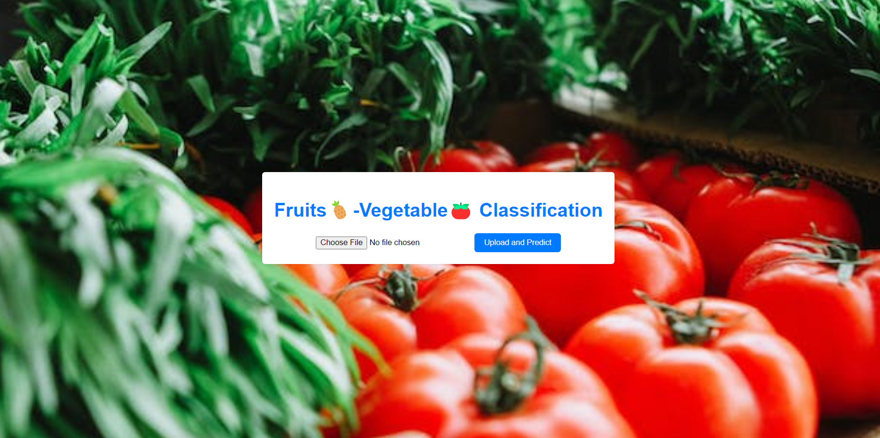

**Fig.9.1.1 Home page**

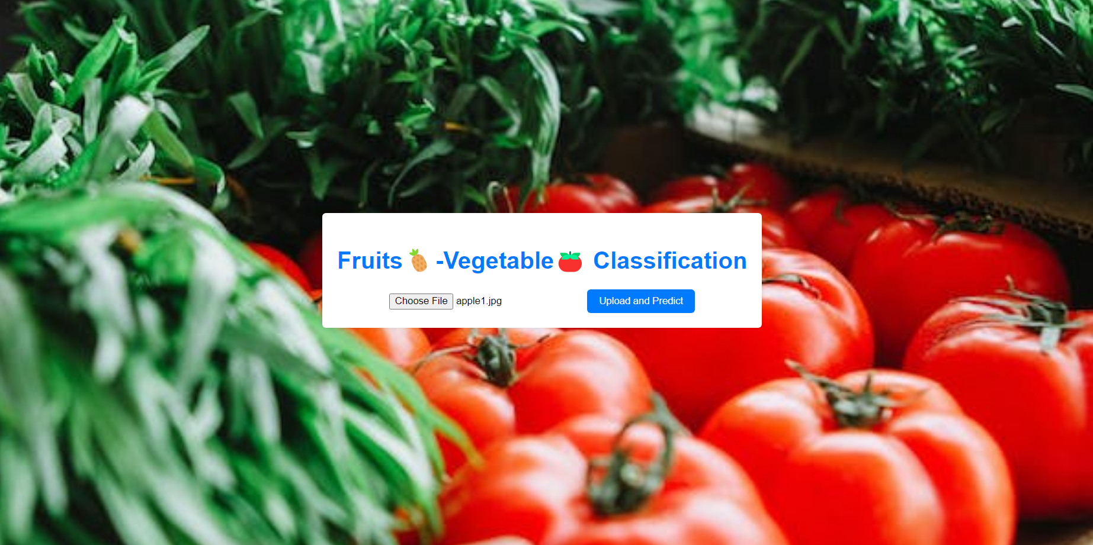

**Fig.9.1.2 uploading file page**

In this the user has chosen the file and to get the output, the upload and predict button has to clicked.

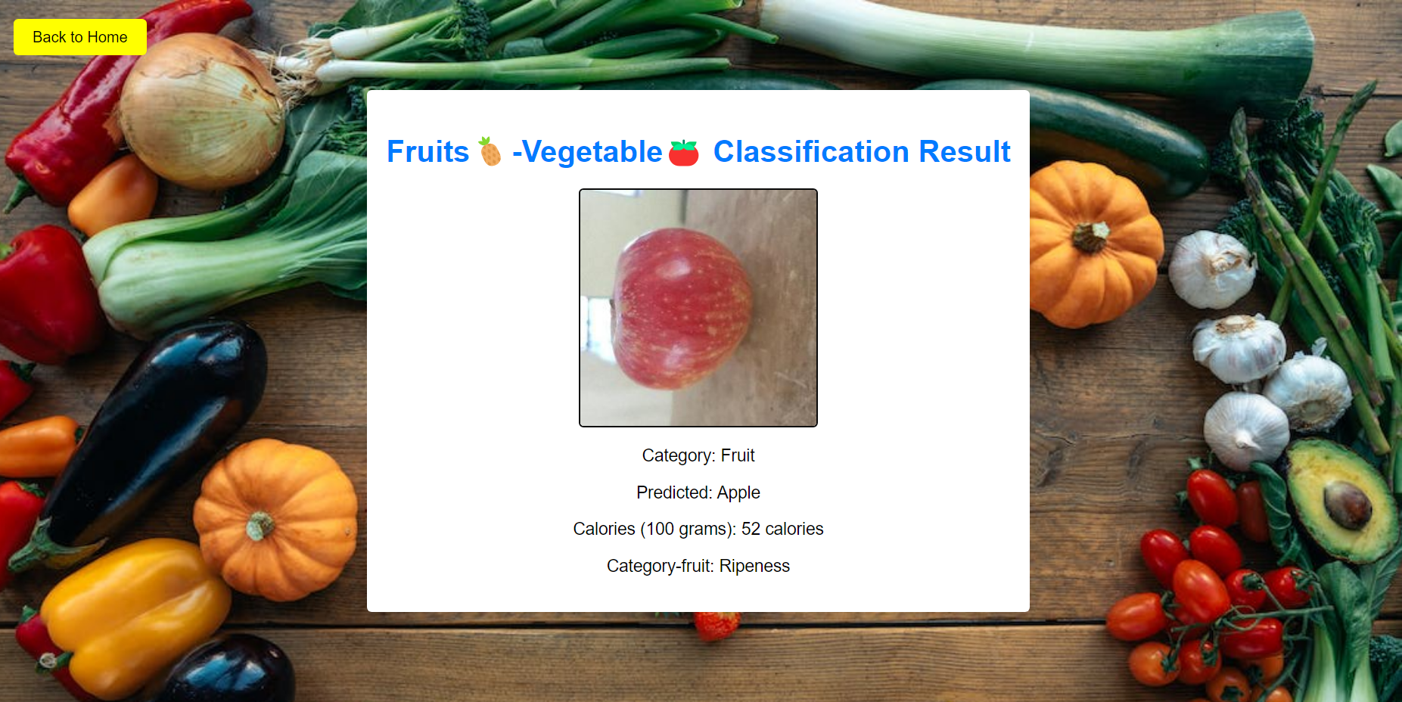

**Fig 9.1.3 Result page 1**

In this, the user will get the actual output, (i.e) the name of the fruit, calories of the fruit and the ripeness of the fruit.

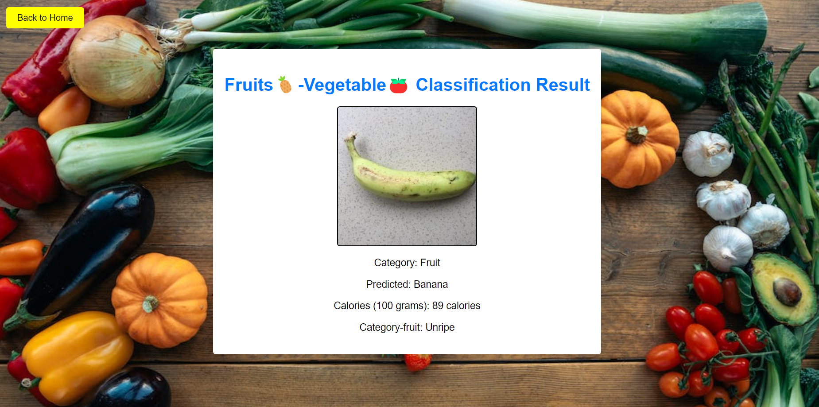

**Fig.9.1.4 Result page 2**

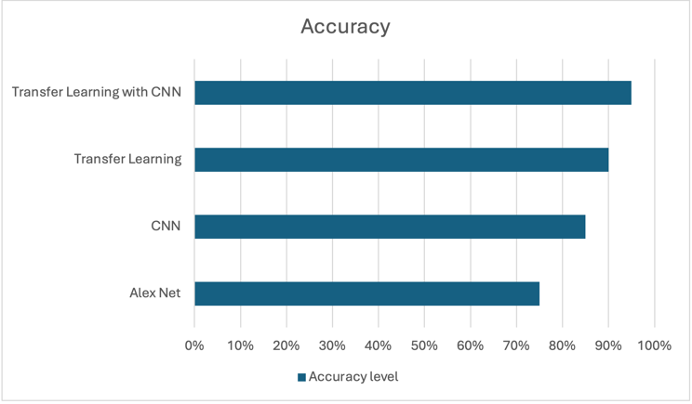

**Fig.9.1.5 Pre-trained models vs proposed model accuracy**

The system's accuracy improved significantly when compared to baseline models. This improvement can be attributed to the CNN architecture's depth and sophistication, as well as the diverse feature set gained from the pre-trained models employed in transfer learning.

Efficiency in Training and Adaptability: One significant effect was the reduction in training time achieved through the application of transfer learning. The system required fewer computer resources and data for training, proving its capacity to adapt to diverse varieties of fruits and ripeness stages with few changes.

Practical Application in the Agricultural Industry: The system's usefulness in real-world circumstances was examined. Integration with existing sorting and quality control procedures is being discussed, with a focus on the possibilities.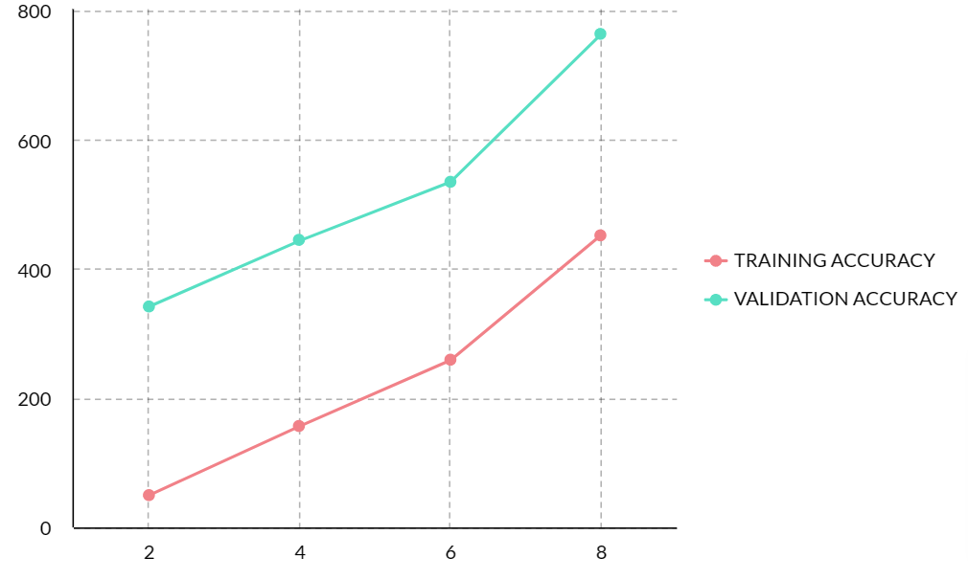

**Fig.9.1.6 Training and validation accuracies**

Limitations and Challenges: The system's limitations, such as its performance in different lighting settings and with fruits that have minor maturity signs, were also explored. These challenges provide up options for future advancements, such as increasing dataset diversity and investigating more.

Broader Implications: Finally, the broader implications of this technology were discussed, notably its role in decreasing food waste, improving supply chain efficiency, and contributing to sustainable agriculture practices. The system's ability to adapt to other agricultural products outside apples was also explored, emphasizing its flexibility.

Finally, the development of a fruit classification and ripeness detection system based on Convolutional Neural Networks (CNN) and transfer learning represents a significant advancement in agricultural technology. This system demonstrates the possibility for combining deep learning techniques into useful, real-world applications. Using pre-trained models, the suggested system provides a more efficient and accurate way to fruit sorting, overcoming the limitations of existing methods. It not only improves classification and ripeness detection accuracy, but also helps to reduce food waste and improve supply chain management.

**9.2 Conclusion**

In culmination, the project uses CNN stands as a groundbreaking solution that harnesses Convolutional Neural Networks (CNNs), Deep learning approach to redefine the landscape of fruit detection and classification with ripeness levels. By seamlessly integrating cutting-edge technology, the project addresses inherent challenges in existing methods, introducing a paradigm shift characterized by heightened accuracy and automated ripeness assessment. This innovation not only streamlines fruit sorting operations but also elevates quality control measures, reducing waste and aligning with modern sustainability goals. With its intuitive interface, scalability, and ethical considerations, the project resonates across various industries, offering a transformative tool that reshapes fruit processing and distribution. By embodying precision, efficiency, and forward-thinking principles, the project paves the way for a future where technology augments our capacity to interact with and utilize natural resources.

Finally, the creation of a fruit classification and ripeness detection system based on Convolutional Neural Networks (CNN) and transfer learning is a big step forward in agricultural technology. This system demonstrates the possibility for combining deep learning techniques into useful, real-world applications. Using pre-trained models, the suggested system provides a more efficient and accurate way to fruit sorting, overcoming the limitations of existing methods. It not only improves classification and ripeness detection accuracy, but also helps to reduce food waste and improve supply chain management.

This revolutionary strategy has the potential to transform the agricultural business by delivering a scalable and resource-efficient solution that can be tailored to different fruit varieties and conditions. The incorporation of such technology may result in more sustainable agriculture operations, guaranteeing that high-quality, ripe fruits reach consumers, increasing consumer satisfaction and encouraging healthy eating habits. Furthermore, the system's ability to continuously learn and improve via feedback mechanisms foreshadows a future in which agricultural technology adapts in response to changing demands and situations. In essence, this study demonstrates the revolutionary impact of merging advanced computational approaches with sector-specific needs, paving the way for future advancements in agriculture and beyond.

This revolutionary strategy has the potential to transform the agricultural business by delivering a scalable and resource-efficient solution that can be tailored to different fruit varieties and conditions. The incorporation of such technology may result in more sustainable agriculture operations, guaranteeing that high-quality, ripe fruits reach consumers, increasing consumer satisfaction and encouraging healthy eating habits. Furthermore, the system's ability to continuously learn and improve via feedback mechanisms foreshadows a future in which agricultural technology adapts in response to changing demands and situations. In essence, this work demonstrates the revolutionary impact of merging advanced computational approaches with sector-specific needs, paving the way for future advancements in agriculture and beyond.

Future research in fruit classification and ripeness evaluation will focus on applying cutting-edge methods like transfer learning and convolution neural networks (CNNs) to improve the process' accuracy and efficiency. Pre-trained models on large datasets can be used to improve performance on smaller fruit datasets, so transfer learning does not require a significant amount of labeled data. By integrating CNNs, complex information from fruit photos may be extracted, improving the system's capacity to differentiate between various fruit varieties and determine ripeness. Optimizing model architectures, investigating new data augmentation techniques, and creating real-time applications for use in the food and agriculture sectors could be the main areas of future research.

## 10. References

1. Asrol, Muhammad, Ditdit Nugeraha Utama, and Franz Adeta. "Real-Time Oil Palm Fruit Grading System Using Smartphone and Modified YOLOv4." *IEEE Access* (2023).
2. Nur-E-Aznin Mimma, Sumon Ahmed, Tahsin Rahman, Riasat Khan, "Fruits Classification and Detection Application Using Deep Learning", Scientific Programming, vol. 2022, Article ID 4194874, 16 pages, 2022.
3. Hossain, M. Shamim, Muneer Al-Hammadi, and Ghulam Muhammad. "Automatic fruit classification using deep learning for industrial applications." *IEEE transactions on industrial informatics* 15, no. 2 (2018): 1027-1034.
4. Gill, Harmandeep Singh, G. Murugesan, Abolfazi Mehbodniya, Guna Sekhar Sajja, Gaurav Gupta, and Abhishek Bhatt. "Fruit type classification using deep learning and feature fusion." *Computers and Electronics in Agriculture* .
5. Saranya, N., K. Srinivasan, S. K. Pravin Kumar, V. Rukkumani, and R. Ramya. "Fruit classification using traditional machine learning and deep learning approach." In *Computational Vision and Bio-Inspired Computing: ICCVBIC 2019*, pp. 79-89. Springer International Publishing, 2020.211 (2023): 107990.
6. R. Phoophuangpairoj, T. Ngoenrungrueang and S. Audomsin, "Ripeness Classification of a Bunch of Bananas Using a CNN," 2023 International Electrical Engineering Congress (iEECON), Krabi, Thailand, 2023, pp. 180-183.
7. Amin, Umer, Muhammad Imran Shahzad, Aamir Shahzad, Mohsin Shahzad, Uzair Khan, and Zahid Mahmood. "Automatic fruits freshness classification using CNN and transfer learning." Applied Sciences 13, no. 14 (2023): 8087.
8. Turaev, S.; Abd Almisreb, A.; Saleh, M.A. Application of transfer learning for fruits and vegetable quality assessment. In Proceedings of the 2020 14th International Conference on Innovations in Information Technology (IIT), Virtual Conference, 17–18 November 2020.
9. Ni, J.; Gao, J.; Deng, L.; Han, Z. Monitoring the Change Process of Banana Freshness by GoogLeNet. IEEE Access 2020, 8, 228369–228376.
10. Dubey, S.R.; Jalal, A.S. Apple disease classification using color, texture and shape features from images. Signal Image Video Process. 2016, 10, 819–826.
11. Zhang, Y.; Wu, L. Classification of fruits using computer vision and a multiclass support vector [CrossRef] [12] Wang, L.; Li, A.; Tian, X. Detection of fruit skin defects using machine vision system. In Proceedings of the 2013 Sixth International Conference on Business Intelligence and Financial Engineering, Hangzhou, China, 14–16 November 2013; pp. 44–48.
12. Dubey Ram, S.; Jalal, A.S. Application of image processing in fruit and vegetable analysis: A review. J. Intell. Syst. 2015, 24, 405–424.
13. Rocha, A.; Hauagge, D.C.; Wainer, J.; Goldenstein, S. Automatic fruit and vegetable classification from images. Comput. Electron. Agric. 2010, 70, 96–104.
14. Akçay, S.; Kundegorski, M.E.; Devereux, M.; Breckon, T.P. Transfer learning using convolutional neural networks for object classification within X-ray baggage security imagery. In Proceedings of the 2016 IEEE International Conference on Image Processing (ICIP), Phoenix, AZ, USA, 25–28 September 2016.
15. S. G. A, R. Prabha, M. Razmah, T. Veeramakali, S. S and Y. R, "Machine Learning Heart Disease Prediction Using KNN and RTC Algorithm," 2022 International Conference on Power, Energy, Control and Transmission Systems (ICPECTS), Chennai, India, 2022, pp. 1-5, doi: 10.1109/ICPECTS56089.2022.10047501.
16. Senthil, G.A., Prabha, R., Nithyashri, J., Revathi, S., Mohana Priya, R. (2024). An Intelligent System for Plant Disease Diagnosis and Analysis Based on Deep Learning and Augmented Reality. In: Jacob, I.J., Piramuthu, S., Falkowski-Gilski, P. (eds) Data Intelligence and Cognitive Informatics. ICDICI 2023. Algorithms for Intelligent Systems. Springer, Singapore.
17. R. Prabha, G. A. Senthil, P. Suganthi, D. Boopathi, M. Razmah and A. Lazha, "Analysis of Cognitive Emotional and Behavioral Aspects of Alzheimer's Disease Using Hybrid CNN Model," 2022 International Conference on Computer, Power and Communications (ICCPC), Chennai, India, 2022, pp. 408-412, doi: 10.1109/ICCPC55978.2022.10072126.
18. S. Albawi, T. A. Mohammed, and S. Al-Zawi, ‘‘Understanding of a convolutional neural network,’’ in Proc. Int. Conf. Eng. Technol. (ICET), Aug. 2017, pp. 1–6.
19. M. A. Hedjazi, I. Kourbane, and Y. Genc, ‘‘On identifying leaves: A comparison of CNN with classical ML methods,’’ in Proc. 25th Signal Process. Commun. Appl. Conf. (SIU), May 2017, pp. 1–4.

**11. APPENDIX-I**

